**Dashboard and Storyline for Bank Customers in United Kingdom**

*Disclaimer: The above case study is used for educational purpose. Any reference to real facts or real events is purely co-incidental.*

The dashboard and storyline show how bank customers in United Kingdom are scattered in England, Wales, Scotland, and Northern Ireland depending upon the Age, Gender, Job Classification, and bank balance. The dataset contains 4014 rows with 11 columns.

**Sheet 1 – Creation of Map**

The column ‘Region’ is added to show the four countries of United Kingdom. The customers in England are the most and least in Northern Ireland.

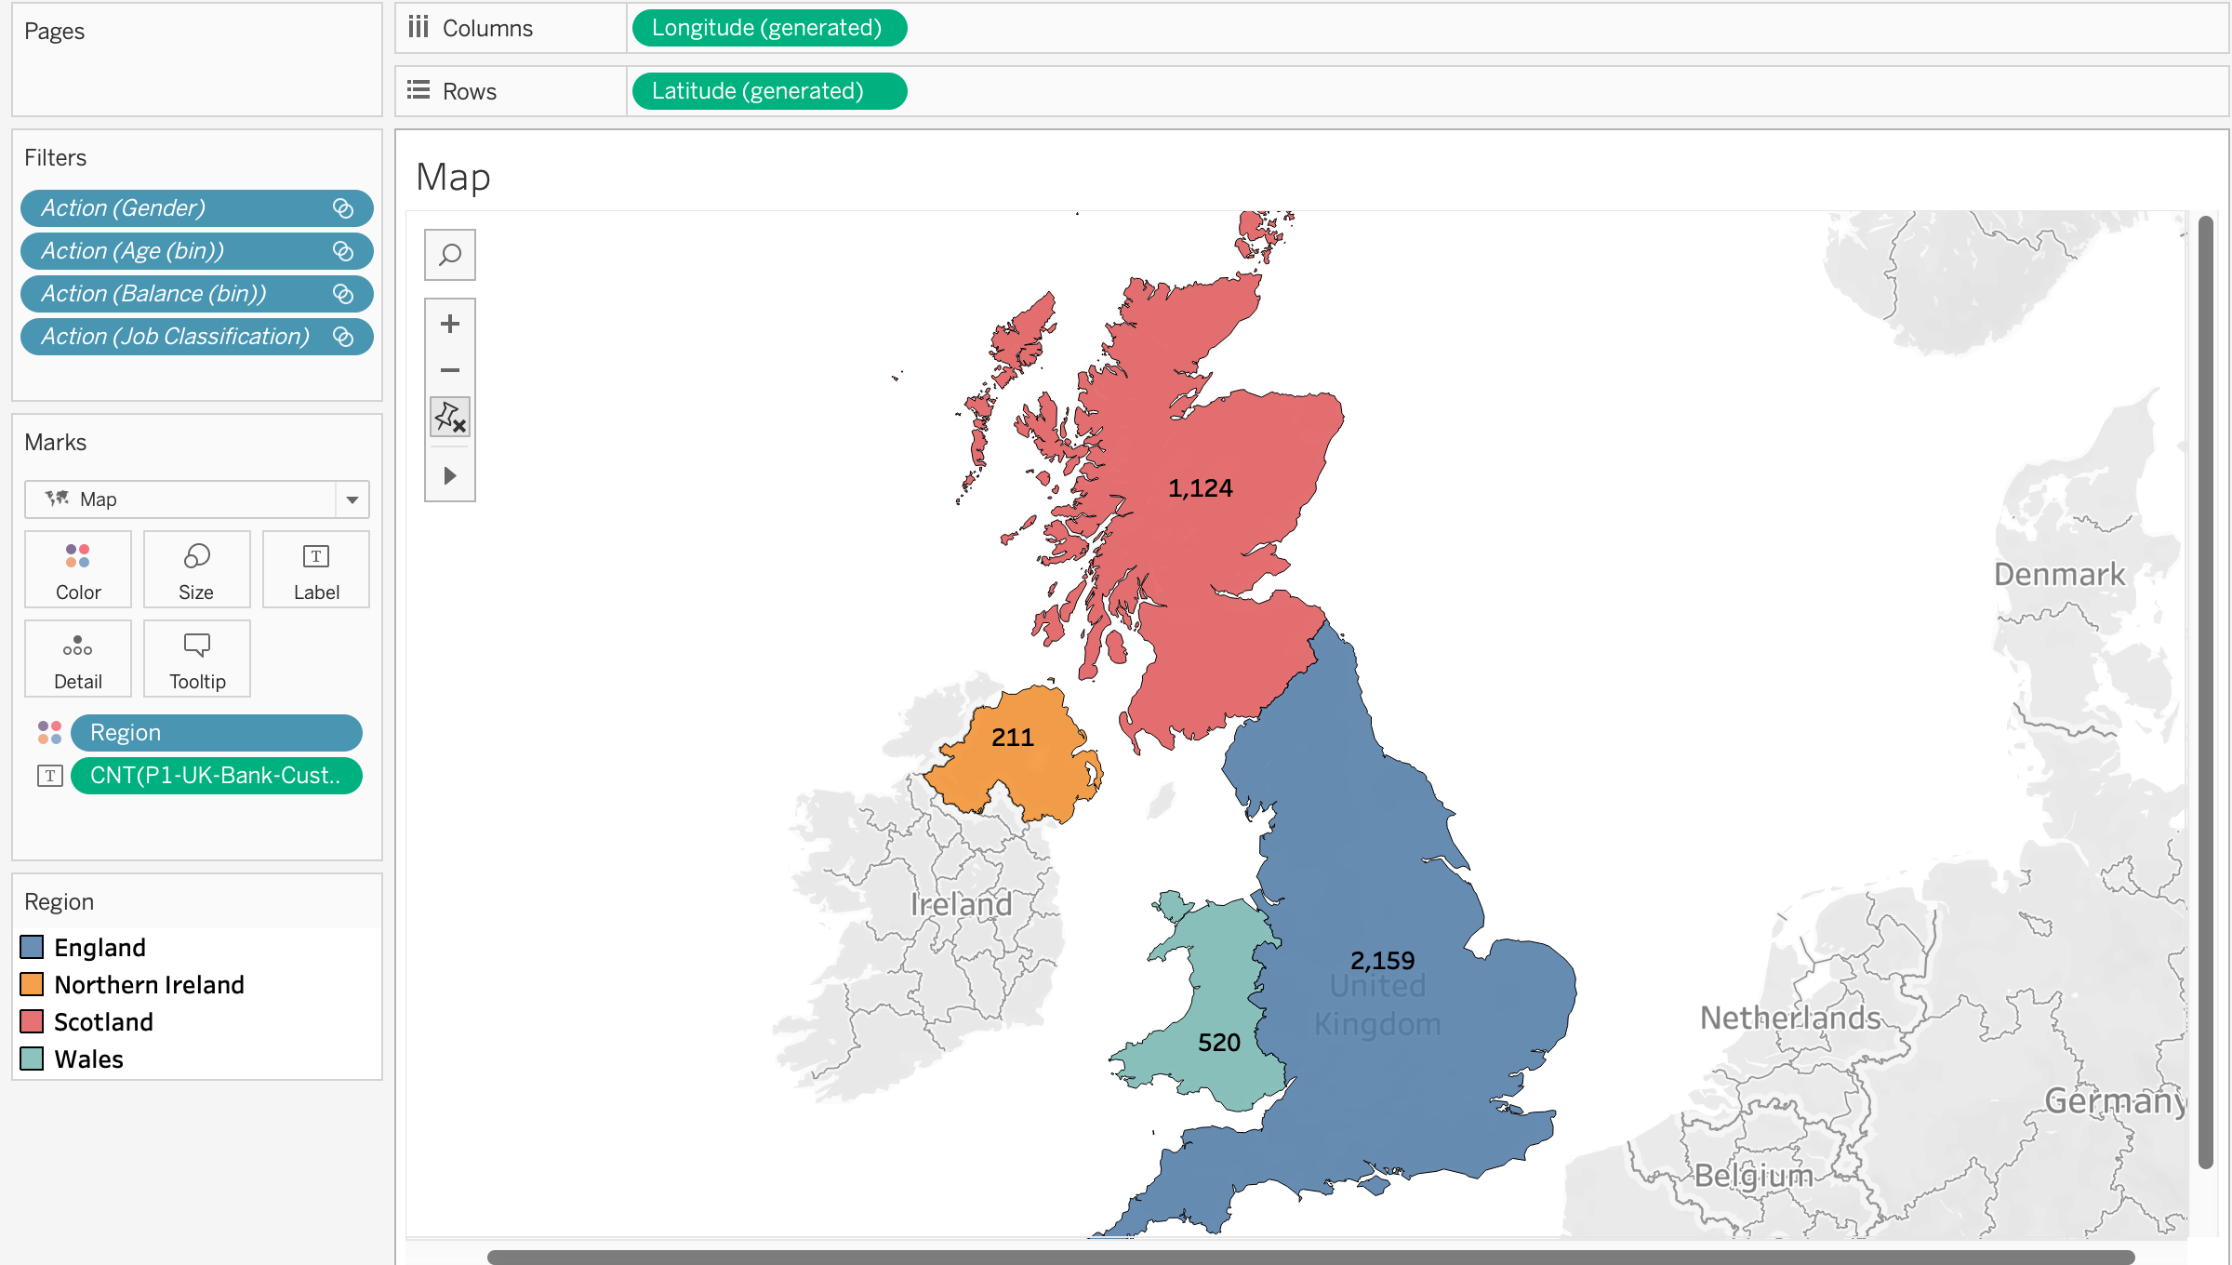

**Sheet 2 - Creation of Pie Chart for Gender Distribution.**

The pie chart is plotted for the Gender distribution which shows the Male percentage is more than that of Female.

**Sheet 3 - Distribution of Age**

The age distribution is shown with the help of Bar chart. Bins are created and the graph shows the percentile of total age distribution.

**Sheet 3 - Distribution by Balance**

The bar graph shows the distribution of the bank balance with more than 24% of the customers fall in between 0 – 15K. The graph is right skewed as expected.

**Sheet 4 - Distribution by Job Classification**

A simple tree chart is created with indicated the job classification which consists of While collar, blue collar, and other.

**Dashboard**

The dashboard is created by arranging all the charts and applying the filter to make data interpretations and analysis to check how customers of UK are using the bank facilities depending on various factors which are depicted below:

The image of the dashboard is shown in the below figure.

* England has maximum number of customers compared to the rest 3 countries. The distribution of balance is still right skewed with while collar jobs more than other two. People who are at the age range 30 – 35 are most contributors in which female percentage is more than that of male.

* When I interpret the data analysis of Scotland, results are different, and range of few factors differ. The distribution of balance is still right skewed and customers with age band 50 – 55 are most of the contributors. The male contributors are 72% and most of them are blue collar jobs.

* Wales have almost 520 total bank customers where contribution of female is more than that of male. The distribution of bank balance is different from that of England and Scotland. It is right skewed but more than 10% of customers have balance more than 40,000 with maximum of the people lie in the age band between 30 and 35.

* Norther Ireland have least bank customer with almost 3/4th of them are female customers. The distribution of balance is right skewed with maximum of the customers are in the band of 25 – 30. Apart from these, the contribution of customers is more who are working in other sectors and not from white or blue-collar jobs.

**Storyline**

The storyline is same representation of the dashboard where each point is depicted with the help of story and adding comments. Below images show the story line of each country along with few annotations.

|  |  |
| --- | --- |
| *England* | *Scotland* |
| *Wales* | *Northern Ireland* |